

Examination
Question/Answer Booklet

CHEMISTRY
STAGE 3AB
Please place your student identification label in this box
Semester 2 examination

Time allowed for this paper
Reading time before commencing work: Ten minutes
Working time for paper: Three hours

Materials required/recommended for this paper

To be provided by the supervisor
Question/answer booklet
Separate multiple-choice answer sheet
Data sheet

To be provided by the candidate
Standard items: Pens, pencils, eraser, correction fluid, ruler, highlighters
Special items: Scientific

Important note to candidates
No other items may be taken into the examination room. It is your responsibility to ensure that you do not have any unauthorised notes or other items of a non-personal nature in the examination room. If you have any unauthorised material with you, hand it to the supervisor before reading any further.

Section | Out of
Multiple Choice | /50
Short Answers | /69
Extended response | /65
Total | /184 | %
Structure of this paper

Section | Suggested working time | Number of questions available | Number of questions to be attempted | % of paper | Marks
ONE  Multiple  choice | 50 minutes | 25 | 25 | 27 | 50
TWO  Short  response | 60 minutes | 13 | 13 | 38 | 69
THREE  Extended  response | 70 minutes | 6 | 6 | 35 | 65
 |  |  | Total | 100 | 184

Instructions to candidates

1. The rules for the conduct of Curriculum Council examinations are detailed in the Student Information Handbook. Sitting this examination implies that you agree to abide by these rules.

2. Answer the questions according to the following instructions.
Section One Answer all questions on the separate multiple-choice answer sheet provided.
Section Two Answer all questions in the spaces provided in this Question/Answer Booklet.
Section Three Answer all questions in the spaces provided in this Question/Answer Booklet.

3. A blue or black ballpoint or ink pen should be used.

- For full marks, chemical equations should refer only to those species consumed in the reaction and the new species produced. These species may be ions [for example Ag⁺ (aq)], molecules [for example NH₃(g), NH₃(aq), CH₃COOH(l), CH₃COOH(aq)] or solids [for example BaSO₄(s), Cu(s), Na₂SO₄(s)].

5. Additional information which may be necessary to answer questions is located on the separate Chemistry data sheet.

SECTION ONE – MULTIPLE CHOICE [50 marks]

This section has TWENTY FIVE (25) questions. Attempt ALL questions.

Answer all questions in Section 1 on the separate Multiple-Choice Answer Sheet provided, using a blue or black pen. Each question in this part is worth 2 marks.

Suggested working time: 50 minutes
_____________________________________________________________________

1. An atom has the first five successive ionisation energies

1.1 2.4 4.6 6.2 37.8 MJ mol⁻¹

Which one of the following elements is it?

a) Aluminium
b) Argon
c) Calcium
d) Carbon

2. Which one of the following pairs of elements is most likely to form an ionic compound?

a) H and O
b) H and F
c) C and F
d) K and F

3. Which one of the following molecules is non-polar; that is, the molecule has no overall dipole moment?

a) H₂CO
b) CO₂
c) H₂O
d) NH₃

4. Which of the following best explain why hexane has a very low solubility in water?

a) Hexane and water each have strong forces between their molecules.
b) Like dissolves like, and these two liquids are unlike.
c) Attractions between hexane and water molecules are much weaker than attractions between water molecules or between hexane molecules.
d) The covalent bonds in a water molecule are exceptionally strong.

5. The following gaseous equilibrium is established at high temperatures in the presence of a finely divided nickel (Ni) catalyst.

CH₄(g) + H₂O(g) ⇌ CO(g) + 3H₂(g); ∆H = +206 kJ mol⁻¹

A particular reaction is carried out using equal amounts of CH₄(g) and H₂O(g). Which one of the following sets of changes in conditions would lead to the greatest increase in the proportion of the reactant converted to products?

Volume of reaction vessel Temperature
a) increased increased
b) increased decreased
c) decreased increased
d) decreased decreased
6. Equal amounts of CH₄(g) and H₂O(g) are added to a reaction vessel and allowed to react. After 10 minutes, equilibrium has been reached. At that time, some H₂ is added to the mixture and equilibrium is re-established.
Which one of the following graphs best represents the changes in the amounts of CH₄ and H₂ in the reaction mixture?

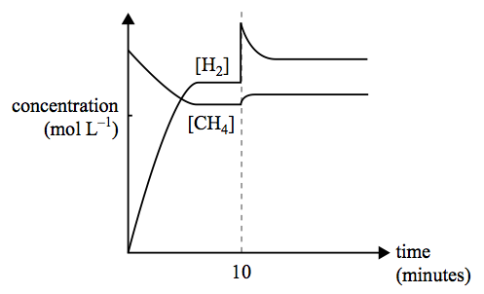
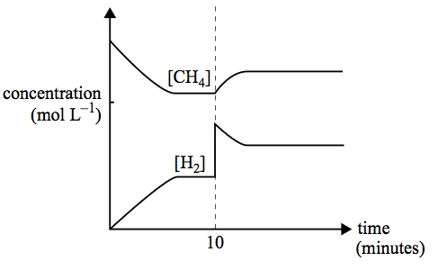
a) b)

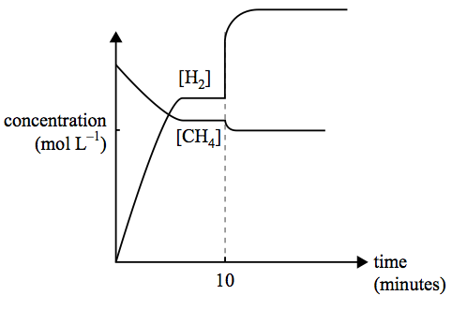
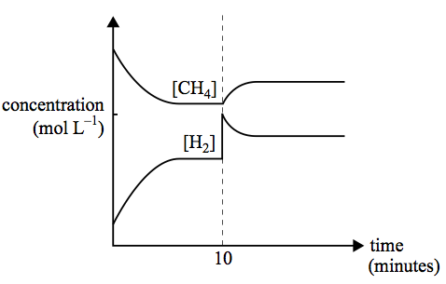
c) d)

7. Hydrogen iodide dissociates into its elements according to the following equation.

2HI(g) ⇌ H₂(g) + I₂(g) ∆H = +9 kJ mol⁻¹

A mixture of H₂(g), I₂(g) and HI(g) rapidly comes to equilibrium in a 2.0 L container. After the reaction has been at equilibrium for 10 minutes, the volume of the container is suddenly reduced to 1.3 L at constant temperature.
Which one of the following graphs best represents the effect of this decrease in volume on the concentration of the gases in the mixture?

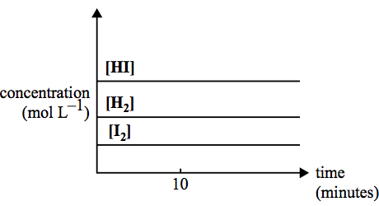
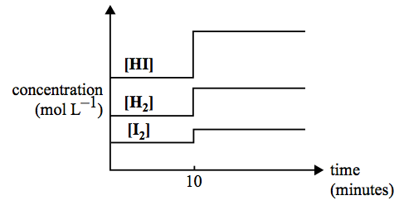
a) b)

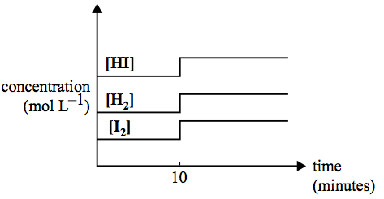

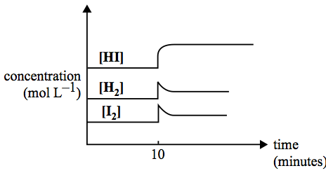
c) d)

8. The two statements below give possible explanations for changes that occur when the temperature of a reaction mixture is increased.

I At a higher temperature, particles move faster and the reactant particles collide more frequently.
II At a higher temperature, more particles have energy greater than the activation energy.

Which alternative below best explains why the observed reaction rate is greater at higher temperatures?

a) I only
b) II only
c) I and II to an equal extent
d) I and II, but II to a greater extent than I

9. The anaesthetic, nitrous oxide, N₂O, decomposes to form an equilibrium mixture of N₂O, N₂ and O₂ according to the following equation.

2N₂O(g) ⇌ 2N₂(g) + O₂(g)

At 25°C, K = 7.3 x 10³⁷ M and at 40°C, K = 2.7 x 10³⁶ M
What valid conclusion can be made from this?

a) The equilibrium concentration of N₂ and O₂ are equal at 25°C.
b) The equilibrium concentration of N₂O is higher at 25° than at 40°C.
c) N₂O is less stable at the higher temperature.
d) The forward reaction is exothermic.

10. Which of the following changes will always shift this equilibrium reaction to the right?

2HI(g) ⇌ H₂(g) + I₂(g) ∆H = -52 kJ

a) Adding a catalyst
b) Increasing the pressure
c) Increasing the temperature
d) Adding more of the reactant

11. A 2.45g sample of lawn fertiliser was analysed for its sulfate content. After filtration and drying, 2.18g of barium sulfate was recovered.

What is the % w/w of sulfate in the lawn fertiliser?

a) 16.8
b) 36.6
c) 46.2
d) 89.0

12. The apparatus shown is used in a first-hand investigation to determine and compare the heat of combustion of three different liquid alkanols.

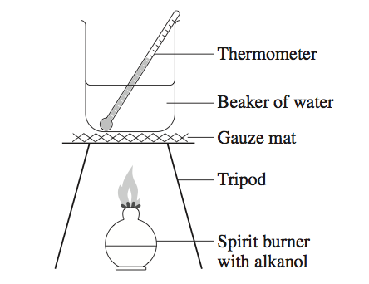

Which is the independent variable?

a) Type of alkanol used
b) Amount of water used
c) Amount of alkanol used
d) Temperature change in the water

13. The Winkler method is used to determine the amount of dissolved oxygen in a sample. In this procedure, oxygen reacts with Mn²⁺ under alkaline conditions to produce a precipitate of MnO(OH)₂.

2Mn²⁺(aq) + O₂(aq) + 4OH⁻(aq) → 2MnO(OH)₂(s)

The precipitate is then dissolved in acid and reacted with iodide, forming iodine and Mn²⁺.

MnO(OH)₂(s) + 2I⁻(aq) + 4H⁺(aq) → I₂(aq) + Mn²⁺(aq) + 3H₂O(aq)

Finally, the amount of iodine produced is determined by reaction with thiosulfate.

I₂(aq) + 2S₂O₃²⁻(aq) → 2I⁻(aq) + S₄O₆²⁻(aq)

When a sample of water was analysed using the Winkler method, a total of 0.60 mol of thiosulfate was used in the reaction.

How many moles of oxygen were present in the original sample?

a) 0.15
b) 0.30
c) 0.60
d) 1.20

14. The sodium salt of propanoic acid (sodium propanoate) is used as a preservative in bread and other baked goods. It can be produced by reacting propanoic acid with sodium hydroxide. In a particular experiment 100 mL of 0.080 M NaOH was added to 100 mL of 0.16 M propanoic acid.
Which of the following statements is/are correct?

I The pH of the resulting solution will be less than that of the propanoic acid solution.
II The resulting solution contains equal numbers of moles of propanoic acid and its conjugate base.
III Before the NaOH was added there were no propanoate ions present.

a) II only
b) III only
c) I and II only
d) I and III only

15. In a flask, 10.0 mL of a 0.100 M HCl solution is diluted to 1.00 L. In a second flask, 10.0 mL of a 0.100 M KOH solution is also diluted to 1.00 L.
Which statement best describes the changes in pH in these flasks?

pH change of the HCl solution pH change of the KOH solution
a) increases by 2 decreases by 2
b) increases by 2 increases by 2
c) decreases by 2 increases by 2
d) decreases by 2 decreases by 2

16. Citric acid, the predominant acid in lemon juice, is a triprotic acid. A student titrated 25.0 mL samples of lemon juice with 0.550 mol L⁻¹ NaOH. The mean titration volume was 29.50 mL. The molar mass of citric acid is 192.12 g mol⁻¹.

What was the concentration of citric acid in the lemon juice?

a) 1.04 g L⁻¹
b) 41.6 g L⁻¹
c) 125 g L⁻¹
d) 374 g L⁻¹

17. Which of the following pairs would form a buffer solution?

a) HCl(aq)/Cl⁻(aq)
b) H₂PO₄⁻(aq)/PO₄³⁻(aq)
c) H₂SO₄(aq)/HSO₄⁻(aq)
d) CH₃COOH(aq)/CH₃COO⁻(aq)

18. The following two unbalanced equations represent processes which are part of the nitrogen cycle.

I NH₃(aq) → NH₄⁺(aq)
II NH₄⁺(aq) → NO₃⁻(aq)

Which one of the following alternatives correctly describes the reactants in each of these processes?

In process I, NH₃(aq) is In process II, the NH₄⁺(aq) ion is
a) an acid reduced
b) a base reduced
c) an acid oxidised
d) a base oxidised

Questions 19 and 20 refer to the following information.

A rechargeable cell, used in laptop computers, contains a metal alloy (designated M) which has hydrogen atoms absorbed on its surface, and nickel in the form of NiO(OH)(s) and Ni(OH)₂(s).
The half reactions, written as reduction reactions, are

H₂O(l) + e⁻ ⇌ H (adsorbed on M) + OH⁻(aq)
NiO(OH)(s) + H₂O(l) + e⁻ ⇌ Ni(OH)₂(s) + OH⁻(aq)

While this cell is generating electricity, the metal alloy acts as the anode.

19. When this cell is generating electricity

a) NiO(OH) acts as the oxidant.
b) the concentration of OH⁻ ions in the cell increases as the cell discharges.
c) OH⁻ ions produced at the negative electrode migrate to the positive electrode.
d) electrons flow in the external circuit from the positive to the negative electrode.

20. When the cell is recharged, which one of the following processes occurs at the electrode connected to the positive terminal of the external power source?

a) reduction of H₂O(l)
b) reduction of NiO(OH)(s)
c) oxidation of Ni(OH)₂(s)
d) oxidation of H (adsorbed on M)

21. Many reactions occurring in plant and animal cells involve a chemical called nicotinamide adenine dinucleotide, NAD⁺. One such reaction is

2NADH(aq) + 2H⁺(aq) + O₂ ⇌ 2NAD⁺(aq) + 2H₂O(l)

It has been suggested that this reaction could be used in biochemical fuel cells to power pacemakers used to control irregular heartbeats.

If this reaction were performed in a fuel cell, NADH would

a) undergo oxidation at the anode.
b) undergo reduction at the cathode.
c) undergo reduction at the anode.
d) undergo oxidation at the cathode.

22. An electrochemical cell is set up as shown in the diagram.

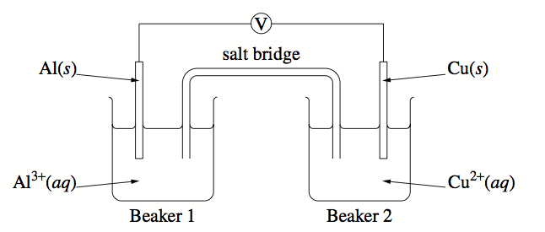

What are two observations for this electrochemical cell?

 | Observation 1 | Observation 2
a) | A reading was shown on the voltmeter | In Beaker 2 the solution became a darker blue
b) | In Beaker 2 the blue solution faded | A reddish precipitate formed on the copper electrode
c) | A grey precipitate formed on the aluminium electrode | In Beaker 2 the solution became a darker blue
d) | Electrons moved through the voltmeter | A reddish precipitate formed on the copper electrode

23. Iron pipes are used to transport natural gas to cities. Corrosion occurs when water droplets sit on the outer surface of the iron pipe.
Miniature galvanic cells are created, with regions such as those below, that act as anodes and cathodes.

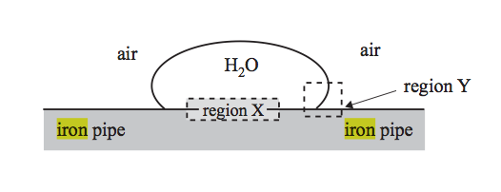

The type of region and reaction occurring at X in the cell is

Region Reaction
a) anode Fe(s) → Fe²⁺(aq) + 2e⁻
b) cathode Fe(s) → Fe²⁺(aq) + 2e⁻
c) anode O₂(g) + 2H₂O(l) + 4e⁻ → 4OH⁻(aq)
d) cathode O₂(g) + 2H₂O(l) + 4e⁻ → 4OH⁻(aq)

24. In which of the following alternatives are the three compounds listed in order of increasing boiling point?

a) Pentane, butan-1-ol, propanoic acid
b) Propanoic acid, butan-1-ol, pentane
c) Propanoic acid, pentane, butan-1-ol
d) Butan-1-ol, propanoic acid, pentane

25. Terylene (polyester) is a condensation polymer. Part of the structure of the polymer is shown.

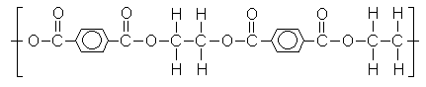

What are the two monomers that form this polymer?

 | Monomer 1 | Monomer 2
a) | 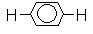 | 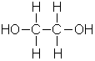
b) | 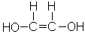 | 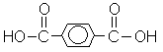
c) | 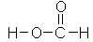
d) |  | 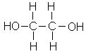

SECTION TWO – SHORT RESPONSE [69 marks]

Section Two contains THIRTEEN (13) questions. Attempt ALL questions in the spaces provided.

In this section, unless asked to write molecular equations, chemical equations should refer to those species consumed in the reaction and the new species produced.

These species may be ions [for example Ag⁺(aq)], molecules [for example NH₃(g), NH₃(aq), CH₃COOH(l), CH₃COOH(aq)] or solids [for example BaSO₄(s), Cu(s), Na₂SO₄(s)].

Suggested working time: 60 minutes
_____________________________________________________________________

Question 1 [4 marks]

Mayonnaise is an example of an oil-in-water emulsion. It is stabilised by the addition of egg yolk, which contains the emulsifier (wetting agent) lecithin (structure below).

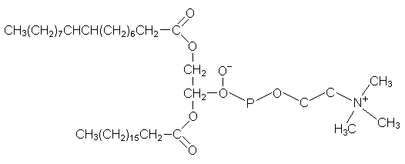

In terms of its structure, explain why the lecithin molecule is able to act as an emulsifier.

The long hydrocarbon chain is non-polar and so is soluble in oil as it is able to establish dispersion forces with the oil molecules.
The head is ionic and is soluble in water as it forms ion-dipole attractions
This combination allows the mixing of oil and water in micelles (diagram is a good idea).
(4 marks)

Question 2 [5 marks]

The diagram shows the wreck of an iron ship sitting on the bottom of the ocean at a great depth.

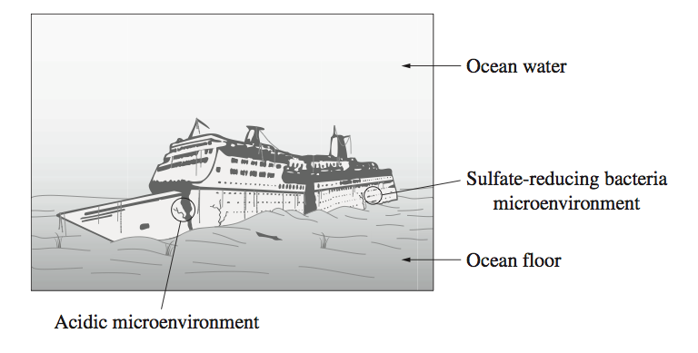
a) Identify the gas dissolved in water that causes corrosion.

Oxygen
(1 mark)

b) Outline the effect of temperature and pressure on the solubility of gases in water.
Gases are more soluble in water at low temperatures and high pressures.
(2 marks)

c) Microenvironments are localised areas where conditions are different from those in the surrounding areas.

Explain the effect of each microenvironment on the rate of corrosion of the iron ship. Include at least one balanced chemical equation in your answer.

The acidic micro-environment increases the rate of corrosion – Fe → Fe²⁺ + 2e⁻
as 2H⁺ + 2e⁻ → H₂.
The sulfate reducing bacteria reduce sulphates in the water to acidic species such as H₂S.
H₂S ⇌ H⁺ + HS⁻, contributing to an increased rate of corrosion.
There may be some reduction of moist air, forming hydroxide ions which may neutralise the acidic environment.

(2 marks)

Question 3 [2 marks]

A fuel cell that can provide power for buses is the phosphoric acid fuel cell, PAFC. The electrolyte is concentrated phosphoric acid and the reactants are hydrogen and oxygen gases.
A simplified sketch of a phosphoric acid fuel cell is given below.

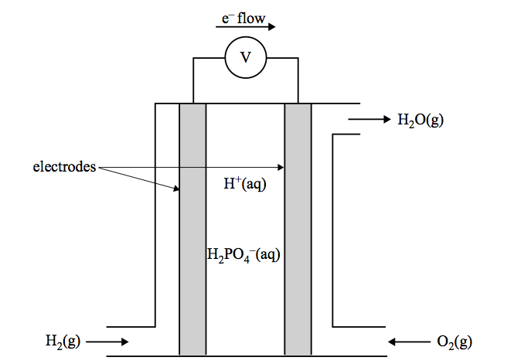

Give the equation for the half cell reaction that takes place at the

i. anode of this cell

H₂ → 2H⁺ + 2e⁻
(1 mark)

ii. cathode of this cell

O₂ + 4H⁺ + 4e⁻ → 2H₂O
(1 mark)

Question 4 [3 marks]

A rechargeable galvanic cell, based on nickel and cadmium (NiCd cell), has been commercially available for a number of years and has been used to power small appliances such as mobile phones. A simplified diagram of a NiCd cell is given below.

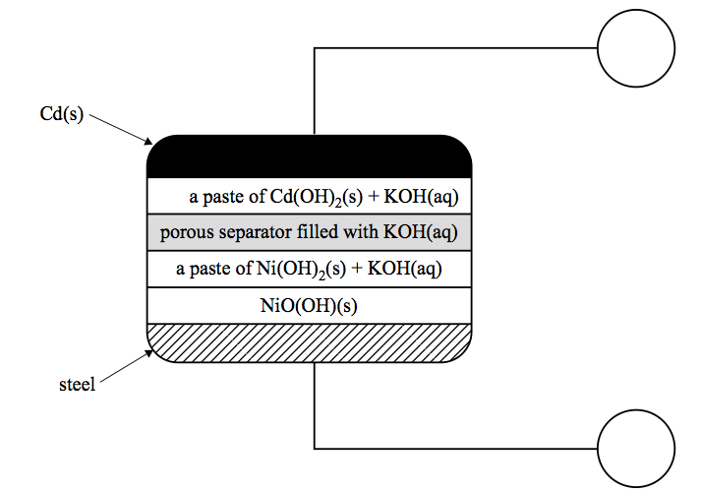
Anode
Cathode
The overall cell reaction for the cell when discharging is

Cd(s) + 2NiO(OH)(s) + 2H₂O(l) → Cd(OH)₂(s) + 2Ni(OH)₂(s)

a) Identify the cathode and the anode electrodes by writing their name in the circles provided in the diagram.
(1 mark)

b) What features of this secondary cell enables it to be recharged?

All products retained within the cell.
Both discharge reactions are reversible.
(1 mark)

c) Give the equation for the half reaction that takes place at the anode when the cell is discharging.

Cd + 2H₂O → Cd(OH)₂ + 2H⁺ + 2e⁻

Or Cd + 2OH⁻ → Cd(OH)₂ + 2e⁻

(1 mark)

Question 5 [5 marks]

The diagram represents three separate petri dishes each containing a mixture of agar, sodium chloride solution, phenolphthalein and an indicator which turns blue in the presence of Fe²⁺. Nails are added to each dish.

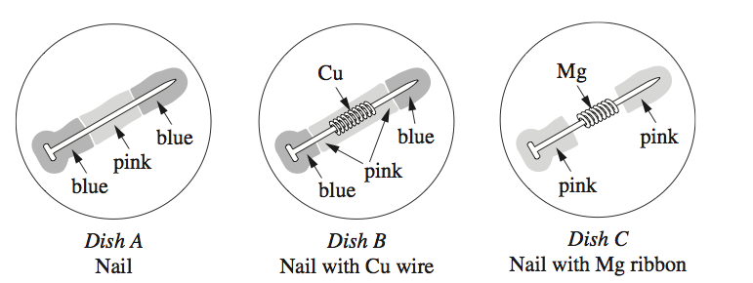

a) Why does the mixture contain sodium chloride solution?

Provide an electrolytic environment to allow migration of ions.
(1 mark)

b) Write two half equations for the reactions occurring in Dish B.

Fe → Fe²⁺ + 2e⁻
2H₂O + O₂ + 4e⁻ → 4OH⁻
(2 marks)
MORE THAN 50% OF STUDENTS GAVE AN EQUATION INVOLVING COPPER

c) In which dish would the nail be protected from corrosion? Explain your answer.

Dish C
Magnesium has a higher oxidation potential than the iron nails.
(2 marks)

Question 6 [4 marks]

a) Calculate the pH of a 0.2 mol L⁻¹ solution of hydrochloric acid.

HCl → H⁺ + Cl⁻
[H⁺] = 0.2 pH = -log 0.2 = 0.69
(1 mark)

b) Calculate the pH after 20mL of 0.01 mol L⁻¹ sodium hydroxide is added to
50 mL of 0.2 mol L⁻¹ hydrochloric acid. Include a balanced chemical equation in your answer.

HCl + NaOH → NaCl + H₂O
n = cv n = cv
n = 0.01 mol
n = 0.002 mol
n(x¹s) = 0.01 – 0.002 = 0.0098 mol
pH = 0.85
(3 marks)

Question 7 [5 marks]

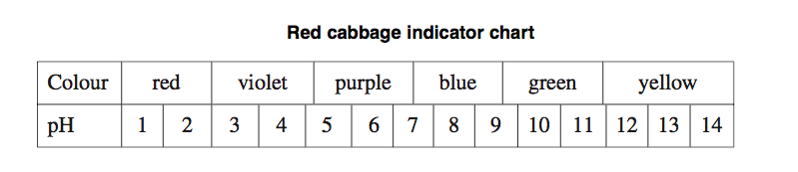

a) State what colour the red cabbage indicator would be in a 0.005 mol L⁻¹ solution of H₂SO₄. Show your working.

pH = -log 0.01 = 2
∴ red
(1 mark)

b) Using the red cabbage indicator, what colour would the solution be if 10 mL of 0.005 mol L⁻¹ H₂SO₄ was diluted to 100 mL?

c(H₂SO₄) = 0.001
pH = 3 ∴ violet
(1 mark)

c) What volume of 0.005 mol L⁻¹ KOH is required to neutralise 15 mL of the diluted solution of H₂SO₄?

H₂SO₄ + 2KOH →
n = cv n(KOH) = 7.5 x 10⁻⁶ x 2
= 0.0005 x 0.015 = 1.5 x 10⁻⁵
= 7.5 x 10⁻⁶ mol V = ,n-c. = ,1.5 𝑥 ,10-−5.-0.005.
= 0.003 L
(3 mL)
(3 marks)

Question 8 [3 marks]

A ‘QwikCure’ pack, used to treat sporting injuries, contains a bag of water inside a larger bag of finely powdered ammonium nitrate, NH₄NO₃. Squeezing the pack causes the bag of water to break and the NH₄NO₃ to dissolve. The change of energy that occurs can be used to treat an injury.

NH₄NO₃(s) → NH₄NO₃(aq); ∆H = +25 kJ mol⁻¹

a) Suppose the activation energy of the reverse reaction is 35 kJ mol⁻¹.

i. Explain the meaning of the term ‘activation energy’.

Difference between the enthalpy of reactants and the minimum energy required for collisions to be successful.
(1 mark)

ii. On the graph below, sketch an energy profile diagram showing the changes
that occur in chemical energy as the NH₄NO₃ powder dissolves.

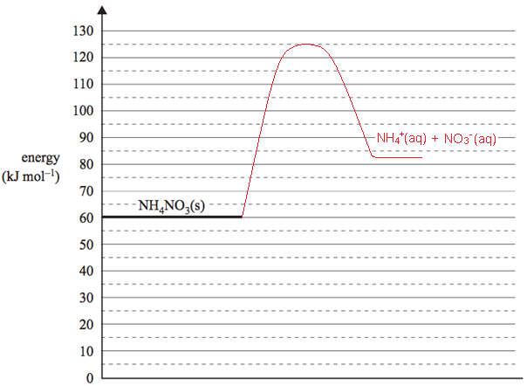
Reaction progress (2 marks)

Question 9 [9 marks]

Complete the table below.
For the dot diagrams, show all valence electron pairs as : or –
For the shapes, either a name or a diagram should be given.
For the intermolecular force, only the principal force operating in a pure sample of the substance in the solid state should be given.

Substance | Dot diagram | Shape | Intermolecular force
Propanone  C₃H₆O | 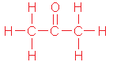 | Trigonal planar | Dipole to dipole
Monochloroacetic acid  C₂H₃ClO₂ | 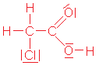 | No shape required | Hydrogen bonding
Dibromoethyne  C₂Br₂ |  | Linear | Dispersion forces

Question 10 [6 marks]

The discovery of element 113 was claimed by teams of Russian and American scientists in February 2004. Following international conventions, it has initially been given the name ununtrium and the symbol Uut, before a permanent name and symbol are given to it.

Uut undergoes rapid radioactive decay but atoms of Uut have been identified with a mass number of 283 and also with a mass number of 284.

a) State the number of subatomic particles in an uncharged Uut atom of mass number 284.

Protons 113 Electrons 113 Neutrons 171
(1 mark)

b) In what group and period is Uut located in the periodic table?

Group 13 Period 7
(2 marks)

c) Give the symbol of the element that is expected to be most similar to Uut in chemical properties.

Tl (accept Hg or Pb)
(1 mark)

d) In terms of atomic structure, explain why the atomic radius of Uut is predicted to be smaller than that of Fr (Z = 87).

Larger core charge attracting electrons in the same shell.
(1 mark)

e) In terms of atomic structure, explain why the first ionisation energy of Uut is predicted to be smaller than that of Al (Z = 13).

Valence electrons in Uut are further from the nucleus and experience more shielding from it.
(1 mark)

Question 11 [9 marks]

Write equations for any reactions that occur in the following procedures. If no reaction occurs write no reaction. In each case describe in full what you would observe, including any colours, odours, precipitates (give the colour), gases evolved (give the colour or describe as colourless). If no change is observed, you should state this.

Barium hydroxide solution is added to a solution of hydrochloric acid.

Equation: H⁺ + OH⁻ → H₂O

Observation: No visible change
(3 marks)

A piece of copper metal is added to concentrated nitric acid.

Equation: Cu + 4H⁺ + 2NO₃⁻ → Cu²⁺ + 2NO₂ + 2H₂O

Observation: Pinkish/brown solid dissolves in a colourless solution forming a blue solution and brown gas
(3 marks)

Ethanol is warmed with acidified acetic acid solution.

Equation: C₂H₅OH + CH₃COOH → CH₃COOC₂H₅ + H₂O

Observation: Colourless liquids form an oily liquid with a fruity smell
(3 marks)

Question 12 [6 marks]

The following table lists the pH of 0.10 M solutions of four different acids at 25°C.

Acid | pH
I | 1.0
II | 3.0
III | 0.7
IV | 2.1

a) Which acid must have more than one acidic hydrogen per molecule? Give a reason for your answer.

Acid III If pH < 1 then [H⁺] > 0.1
(2 marks)

b) Calculate the value of the [OH⁻] present in the solution of acid III.

pH= 0.7 and [H⁺] = 0.1995
[OH⁻] = 1x 10⁻¹⁴ / 0.1995 = 5.01 x 10 ⁻¹⁴ M
(2 marks)

c) Samples of the solutions of acids I and IV are diluted by a factor of 10.
The resulting change in pH units would be
(Tick one of the following boxes.)

greater for acid i than for acid IV

greater for acid iv than for acid I

the same for both acids | #

Give an explanation for your answer.

The pH scale is logarithmic
dilution by a factor of 10 increases the pH of acids by 1 pH point
(2 marks)

Question 13 [8 marks]

The polymer, polyvinylchloride is composed of units of the monomer C₂H₃Cl.

a) Draw the structure of this monomer. (1 mark)

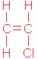

b) Draw a section of the polymer showing at least three repeating units.
(1 mark)
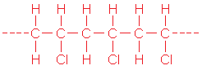

A tripeptide may be represented by the structure shown below.

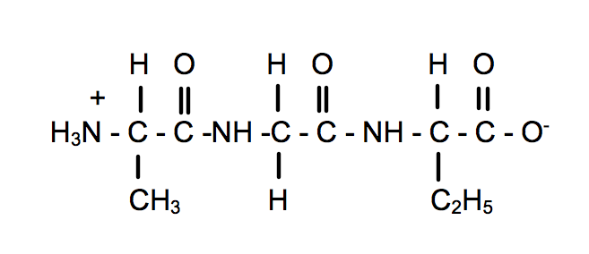

c) Draw structures to show the amino acids from which this polymer is formed.
(2 marks)
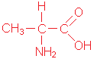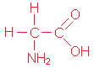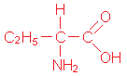

d) Draw a section, with at least three silicon atoms, of the silicone that could be prepared from the silonol shown below. (1 mark)
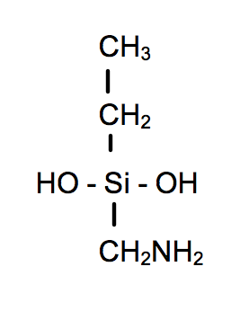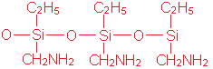

Silicones have a useful range of physical properties including:

- Stable at extreme temperatures
- Water repellent
- Flexible

Choose one of these properties and explain it. (3 marks)

High Temperature Stability
Silicones retain their liquid properties over a wide temperature range. Temp changes do not influence the dispersion forces present as they are only loosely binding the chains.

Water Repulsion
Hydrogen bonding is not possible with water and the chains are essentially non-polar and set up mainly dispersion forces between chains. They are too dissimilar to the intermolecular forces present in water.

Flexibility
Si-O bond is quite long, allowing more flexibility than polymers with C-C bonds. Dispersion forces between silicone chains are weak as the electrons are spread out over a large surface area.

SECTION THREE – EXTENDED RESPONSE [65 marks]

Section Three has SIX (6) questions. Attempt ALL questions in the spaces provided below.

In descriptive responses, marks are awarded for relevant chemical content, including equations, diagrams and illustrative examples of the chemistry you are describing.

Calculations are to be set out in detail. Marks will be awarded for correct equations and clear setting out, even if you cannot complete the calculation. Express numerical answers to three (3) significant figures and provide units where appropriate.

Suggested working time: 70 minutes
_____________________________________________________________________

Question 1 [12 marks]

A particular industrial process involves the following steps.
A(g)
B(g)
B(g)

reaction 1
A(g) + B(g) → 2C(g)
∆H = +100 kJ mol⁻¹
reaction 2
C(g) + B(g) ⇌ D(g)
∆H = -200 kJ mol⁻¹ temperature 500°C pressure 1 atm
separation chamber
Product
D(g)

B(g) and C(g) recycling

a) It is possible to alter the temperature and pressure at which reaction 2 occurs.
In the table below, indicate what effect the following changes to temperature and pressure would have on the rate, equilibrium yield and value of the equilibrium constant, K, for reaction 2.

 | Would the rate of reaction 2 become higher, lower or remain unchanged? | Would the equilibrium yield of reaction 2 become higher, lower or remain unchanged? | Would the value of the equilibrium constant, K, of reaction 2 become higher, lower or remain unchanged?
The temperature of reaction 2 is lowered to 150°C | Lower | Higher | Higher
The pressure of reaction 2 is increased to 5 atm by pumping more B(g) and C(g) into the reaction vessel, at constant temperature. | Higher | Higher | Same
(6 marks)

b) The graph below shows the variation in concentration of reactant and products as a function of time for the following system.

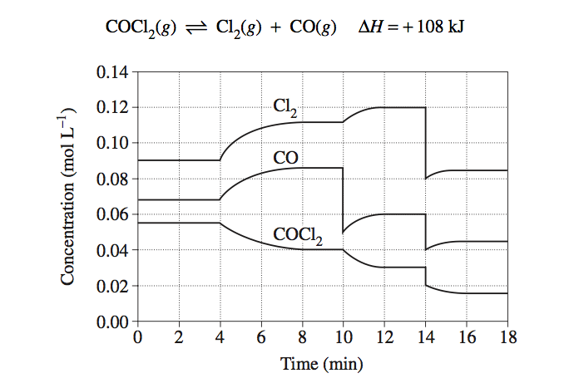

Identify and explain each of the changes in conditions that have shaped the curves during the time the system was observed.

At 4 mins [Cl₂] and [CO] ↑ as the [COCl₂] ↓. Increased temperature has favoured the endothermic pathway.

At 10 mins the [Cl₂] ↑ as [CO] ↓ suddenly and [COCl₂] ↓gradually. Carbon monoxide has been removed from the system, favouring the forward rate.

At 14 mins all concentrations fall as the volume of the container is increased.
(6 marks)

Question 2 [10 marks]

When assessing the alcohol content of wine for labelling purposes, the ethanol may be separated by distillation of the wine and then treated with excess acidified potassium permanganate solution. The reaction mixture is placed in a water bath for several minutes to ensure the complete oxidation of the alcohol to acetic acid.
Iron II sulfate solution is then added to reduce the excess permanganate ion. By this method, the amount of permanganate required to oxidise the alcohol and hence the amount of alcohol, may be determined.
The following results were obtained for a 750 mL bottle of wine, analysed as described above.

Mass of 750 mL wine = 750 g
Vol of 1.500 mol L⁻¹ KMnO₄ added to the distillate = 1250 mL
Vol of 0.5000 mol L⁻¹ Fe²⁺ solution required to titrate the excess KMnO₄ = 447.5 mL

The half-equation for the oxidation of ethanol is:

C₂H₅OH + H₂O → CH₃COOH + 4H⁺ + 4e⁻

a) Calculate the number of moles of KMnO₄ added to the ethanol. (1mark)
n(KMnO₄) = cV = 1.5 x 1.25 = 1.875 mol

b) Calculate the number of moles of KMnO₄ in excess. (3 marks)

5 Fe²⁺ + MnO₄⁻ →
n = cv n(MnO₄⁻) = ,0.22375- / 5.
= 0.5 x 0.447 = 0.04475 mol
= 0.22 375 mol

c) Calculate the number of moles of KMnO₄ that combined with the ethanol.
(2 marks)
1.875 – 0.04475 = 1.83025 mol

d) Calculate the concentration of ethanol in the wine as a percentage by mass.
(4 marks)
5 C₂H₅OH + 4MnO₄⁻ →
n(C₂H₅OH) = ,5-4. x 1.83025 = 2.288 mol
m(C₂H₅OH) = nM = 105.24 g
% C₂H₅OH = ,105.24- / 750. x 100 = 14.03%

Question 3 [12 marks]

A student carried out a first-hand investigation to identify the relationship between the mass of a metal used in a reaction, and the volume of gas produced. The first-hand investigation was carried out at 25°C, and 100 kPa. In each experiment, 200 mL of hydrochloric acid was added to some zinc, and the volume of gas produced was recorded. The diagram shows the equipment used, and the table contains the student’s results.

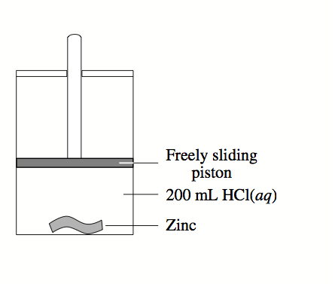
Mass of zinc (g) | Volume of gas collected at 25°C and 100 kPa (mL)
0.12 | 45
0.33 | 125
0.56 | 115
0.83 | 315
0.96 | 365
1.22 | 380
1.64 | 380
1.93 | 380
a) Graph the results from these experiments.

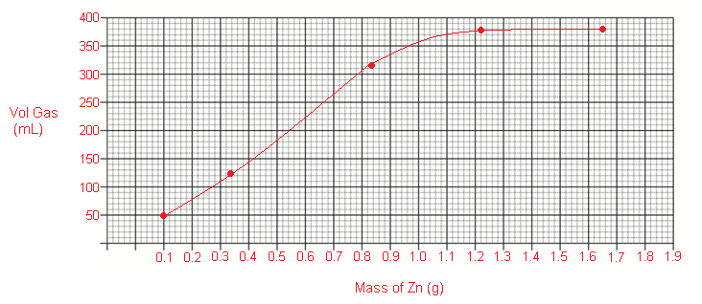
(3 marks)

b) Predict the volume of gas that would be produced in this experiment if 3.00g of zinc had been used. Justify your answer.

380 mL
Acid is the limiting reagent

(2 marks)

c) Calculate the theoretical volume of gas produced at 25°C and 100 kPa by the reaction of 0.56 g of zinc with the 200 mL of hydrochloric acid.

Zn + 2HCl →ZnCl₂ + H₂
n(H₂) = n(Zn) = ,m-M. = ,0.56- / 65.38. = 8.565 x 10³ mol
v = ,nRT-P. = (,8.565 x ,10-3⁻³⁻⁻³. x 8.315 x 298) / -100.
= 0.212 L
(2 marks)

d) A different student carried out the same experiment. She used a constant temperature of 15°C.
Describe the results she would have obtained and explain why these results would vary from those shown above.

The volume of gas would have been smaller as the volume is directly proportional to temperature.
As temperature is a measure of average kinetic energy, low temperature means less KE, thus particles have less capacity to move apart from eachother.

At the lower temperature, the reaction would have been slower as the energy of collisions would have been less and so the time taken for all the acid to react would have been longer.
(5 marks)

Question 4 [10 marks]

The compound known as phenazine (C₁₂H₈N₂) is important in the manufacture of a number of
dyes that are used as biological staining agents in the science of histology. Phenazine is manufactured in a series of stages as shown by the equations below. The efficiencies of the stages are shown in brackets.

Stage 1 (87% efficient)
Concentrated sulphuric and nitric acids are heated together.
HNO₃ + H⁺ → NO₂⁺ + H₂O

Stage 2 (40% efficient)
The hot acid mixture is boiled with benzene to form nitrobenzene.
C₆H₆ + NO₂⁺ + H⁺ → C₆H₅NO₂ + H₂

Stage 3 (62% efficient)
The nitrobenzene is reacted with aminobenzene to form phenazine.
C₆H₅NO₂ + C₆H₅NH₂ → C₁₂H₈N₂ + 2H₂O

(a) If 120 tonnes (1.20 x 10⁸ g) of nitrobenzene are consumed in the manufacturing process in one week of production, calculate the mass of phenazine formed. (3 marks)

n(C₆H₅NO₂) = ,m-M.
n(phenazine) = n(C₆H₅NO₂) x 0.62
= 6.05 x 10⁵ mol m = nM = 1.09 x 10⁸ g

(b) Calculate the volume of 8M nitric acid used in Stage 1 in the same week.
(4 marks)
n(NO₂⁺) = n(C₆H₅NO₂) x ,100- / 40. = 2.44 x 10⁶ mol
n(HNO₃) = n(NO₂⁺) x ,100- / 87.
= 2.803 x 10⁶ mol
V = ,n / c. = 2.803 x 10,-6⁶⁶⁶⁶⁶⁶⁶⁶ / -8. = 3.50 x 10⁵ L
(c) Draw the structures of nitrobenzene and aminobenzene and suggest a structure for phenazine. (3 marks)

Nitro benzene Amino benzene Phenazine

NO₂
NH₂
N

N

Question 5 [9 marks]

Analysis of a block of air freshener indicated that it contained several compounds that could to be separated from each other by dissolving in a number of solvents. One of the ingredients, which dissolved in water, was found to contain only carbon, hydrogen oxygen and nitrogen.
A 1.255 g sample of the compound was burned in air and produced 1.171 g of carbon dioxide and 1.202 g of water.
A second 2.552 g sample was decomposed at high temperature and found to contain 0.7602 g of nitrogen.
A third sample, weighing 1.500 g was vapourised at 150ºC and 101.3 kPa and the vapour occupied 1.108 L.
A fourth sample was dissolved water and tested with phenolphthalein. The indicator
turned pink. The compound was also found to turn acidified potassium dichromate solution from orange to green.

(a) Determine the empirical formula of the compound. (4 marks)
m(C) = 1.171 x ,12- / 44. m(H) = ,2 / -18. x 1.202

%(C) = ,m(C)- / 1.235. = 25.45% %(H) = ,m(H) / 1.255. = 10.64%

m(N) = 0.7602 g

%(N) = ,0.7602 / -2.552. = 29.74% %(0) = 34.12%

C H N O

n = ,25.45-12 ,10.64-1. ,29.79-14. ,34.12-16.

2.12 10.64 2.12 2.13

1 : 5 : 1 : 1

CH₅NO

(b) Determine the molecular formula of the compound. (2 marks)
1.500 g → 1.108 L @ 150°C and 101.3 kPa

n = ,PV- / RT. = ,101.3 x 1.108 / -8.315 x 423. = 3.19 x 10⁻²

M_{r} = ,m / -n. .. = 47 ∴ CH₅NO
(c) Suggest a structure for the compound. (1 mark)

H

H C OH

NH₂

(d) Write an equation to explain why the compound turned phenolphthalein pink.
(2 marks)

H H

H C OH + H₂O ⇌ H C OH + OH⁻

NH₂ NH₃⁺ basic

Question 6 [12 marks]

Consider the information presented in the table below.

Substance | Electrical conductivity of solid | Solubility in water | Solubility in petrol | Melting point (ºC)
Candle wax  C₂₅ H₅₂ | nil | insoluble | soluble | 47
Methanol | nil | soluble | insoluble | -97
Sodium bromide | nil | soluble | insoluble | 734
Lead iodide | nil | insoluble | insoluble | 402
Propyl propanoate | nil | insoluble | soluble | -76

Discuss the similarities and differences in physical properties that are presented by these data.

None of the substances listed possesses mobile ions or delocalised electrons and so none of them is able to conduct electricity.
Candle wax and propyl propanoate are insoluble in water but solute in petrol. As water is a non polar solvent and petrol a non-polar solvent, the solubility indicates that candle wax and propyl propanoate are both non-polar. The principal intermolecular forces acting in these substances are dispersion forces and hence they are able to establish similar forces with petrol molecules. These forces are too dissimilar to the hydrogen bonding found in water and so they do not mix. The low melting points of these compounds are consistent with this.

Methanol and sodium bromide are insoluble in petrol but soluble in water. The forces holding formula units together are different from those in petrol but similar to those found in water. Methanol is able to hydrogen bond to the water and sodium bromide dissociates into Na⁺ and Br⁻, which form ion-dipole attractions with polar water molecules. The hydrogen bonds between methanol molecules are much weaker than the ionic bonds in NaBr, accounting for the large difference in melting points.

Lead iodide is insoluble in both solvents. The electrostatic attraction of the Pb2+ ion for the 1⁻ ions, combined with the presence of some covalency in the bond makes the bonding present too dissimilar or too strong to be disrupted by the forces present in either solvent. This strong bonding also accounts for the relatively high melting point of PbI₂.

